Reg ID - GO_STP_6834

Day 15:

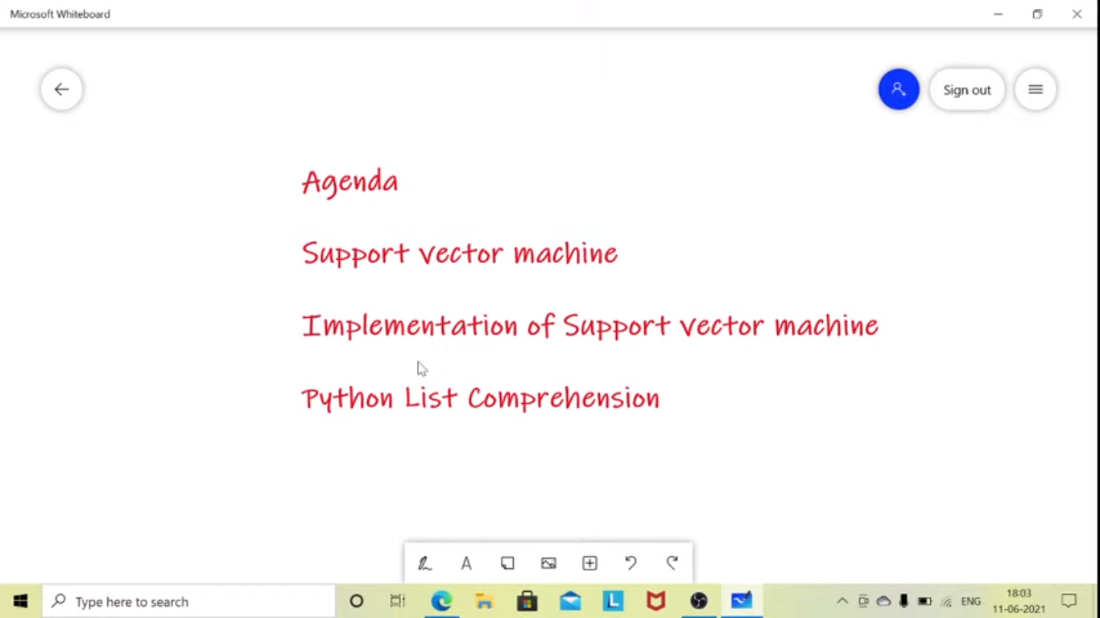

* Supervised ML
* Can be used for both classification and regression
* Commonly we used for classification

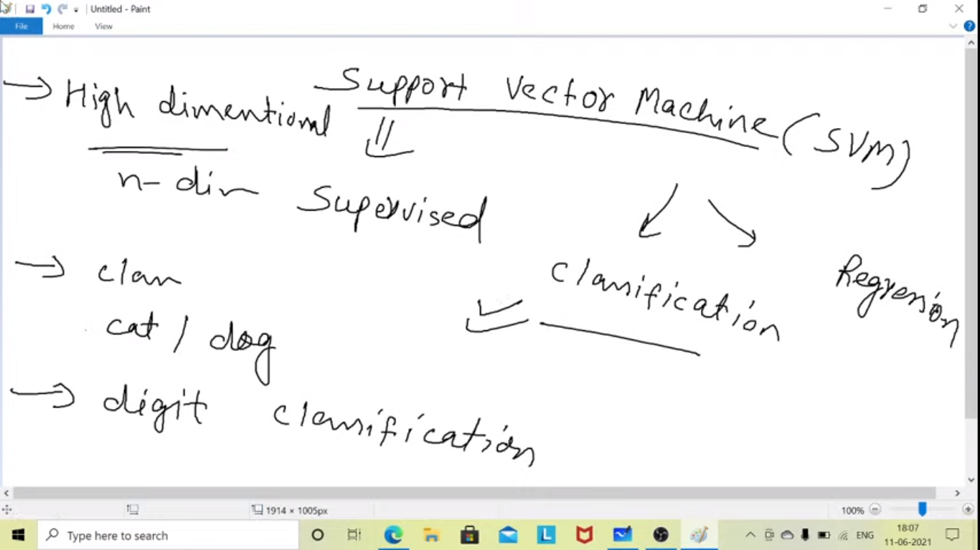

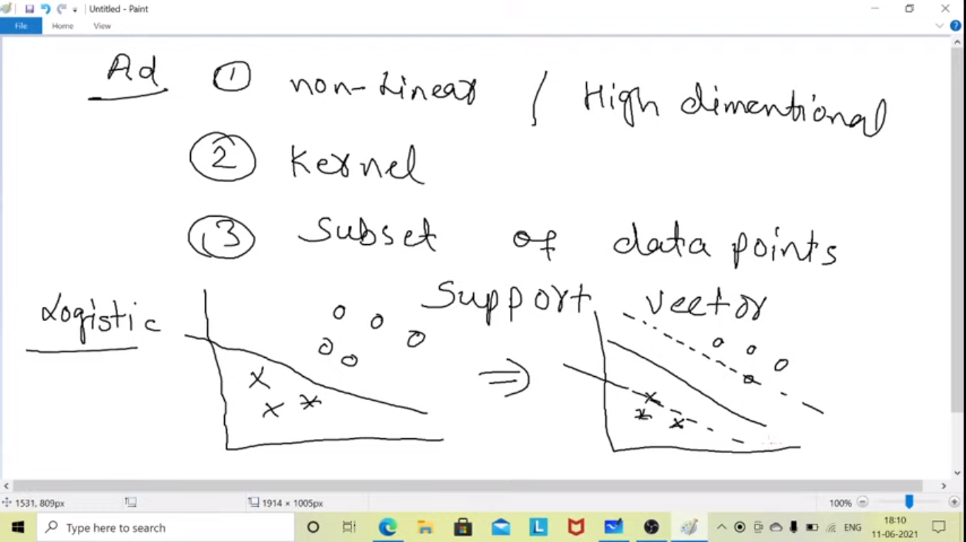

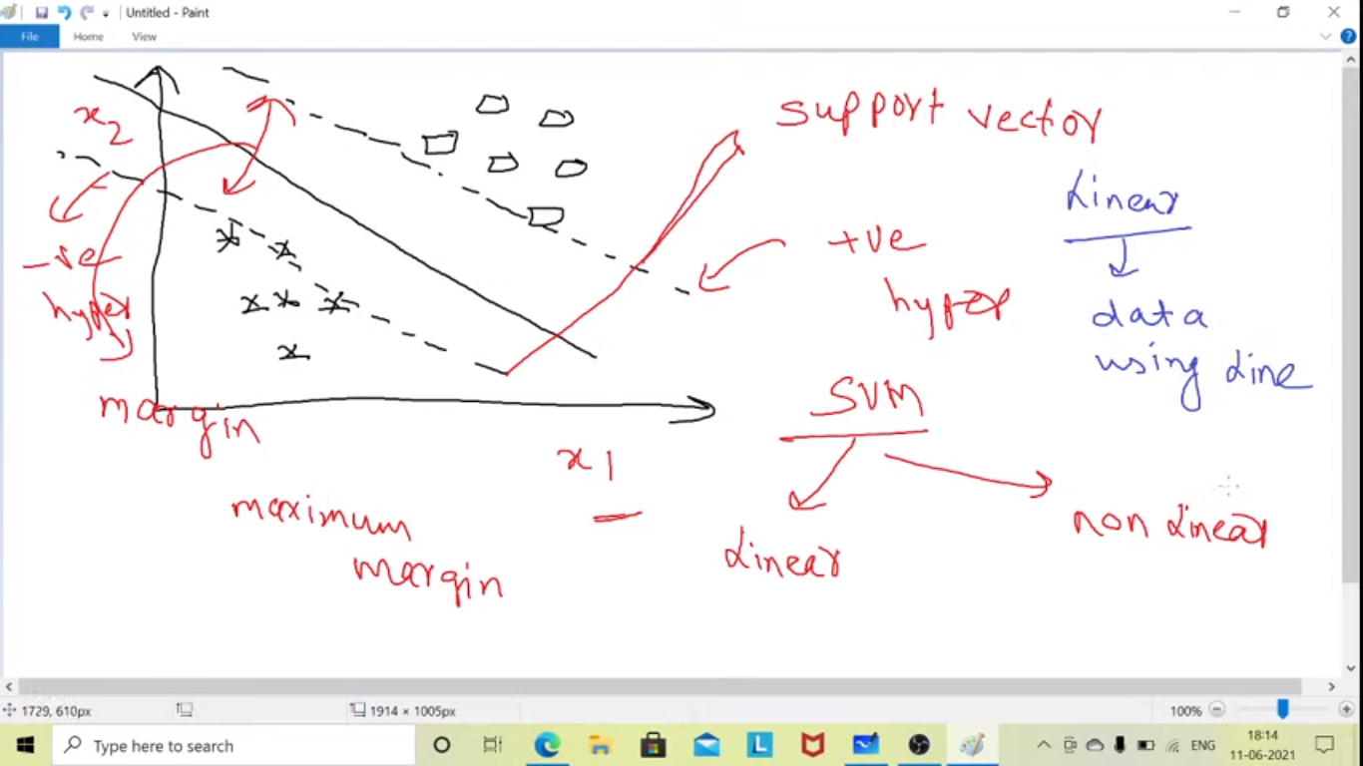

The distance between support vector line is margin

The points which comes on support vector line.

